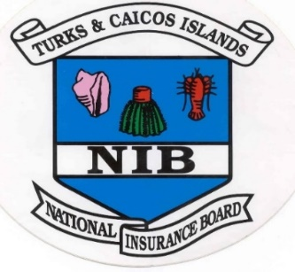
Turks & Caicos Islands National Insurance Board
Board Meeting Summary

The National Insurance Board met on Thursday, January 22, 2026, via Microsoft Teams

At this meeting, the Board Members:

- Accepted the Following Reports

- CEO’s Update January 2026

- Approved the following:

- Board Papers:
The Board approved the following Board Papers:

- Board Meeting Summary
The Board approved the Board Meeting Summary for December 12, 2025 for circulation to staff and publication on the NIB website.
- Strategic Plan’s Targets
The Board approved the targets for the continued strategic direction of NIB.
- Cybersecurity Recommendations
The Cybersecurity recommendations were accepted by the Board.

- Training Opportunities
The Board approved training events for several Staff to further enhance their understanding of the changing dynamics of social security.

- Received the following Matters Arising Updates:

- National Insurance Audit Update
The Management Letter has been completed. The document will be reviewed by the Audit Committee in due course.

- 11th Actuarial Report
The NIB is awaiting the Cabinet’s consideration of the draft legislative amendments to enact the approved recommendations from the 11th Actuarial Report.

- NIB’s Cybersecurity
The recommendations emanating from the Cybersecurity review Was reviewed and approved for implementation.

- Received the following Matters for Consideration:

- Management Meeting
A two-day Management Meeting was held in preparation for the year ahead.
- Received the following Matters for Noting:

- Annual General Staff Meeting
The Board was updated on the Annual General Staff Meeting which was held on January 16, 2026.
- Public Education Tours
The Board was advised of the Public Education Tours that would be conducted across the nation. It would cover pertinent topics including the recently concluded 11th Actuarial Review, the NIB Benefits package, and Compliance. A special effort is being made to target the self-employed sector.

END

