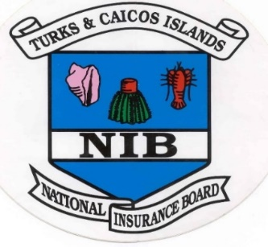
Turks & Caicos Islands National Insurance Board
Extraordinary Board Meeting Summary

The National Insurance Board met on Thursday, January 29, 2026, via Microsoft Teams

At this meeting, the Board Members:

- Accepted the Following Reports

- Financial Controller’s Report
- Benefits Manager’s Report
- Compliance Report
- Annual Report for 2021-2022 and 2022-2023.

- Approved the following:

- Received the following Matters Arising Updates:

- NISS Workshop
The Premier is spearheading a NISS Workshop to review the status and chart the way forward for the initiative. All stakeholder representatives are expected to be in attendance.

- Received the following Matters for Consideration:

- The Strategic Plan’s – Terms of Reference
Terms of Reference for a 4-year Strategic Plan was presented for Board consideration and approval.

- Annual Report
The draft annual reports for 2021/22 and 2022/23 were presented for Board approval.

- Received the following Matters for Noting:

- Public Education Tours
The Board was advised of the Public Education Tour. This is a public education initiative to inform the public, with special emphasis on the self-employed sector, of the outcomes of the 11th Actuarial Review.

- New NIB Building
The Board received initial input from the Management Team regarding the proposed features for the new NIB Office complex.

END

